<!DOCTYPE html>
<html>
<body>
<h2>Converting a JavaScript object And JavaScript Array in to JSON string</h2>

<h3>1. Creating a JSON string from a JavaScript object</h3>
<p id="obj"></p>

<h3>2. Creating a JSON string from a JavaScript Array</h3>
<p id="aray"></p>

<script>
const emp = {EmployeeName: "Ravi", experience: 5, Qualificatio:"B Tech- IT",city: "New Delhi"};
const myJSONObj = JSON.stringify(emp);
document.getElementById("obj").innerHTML = myJSONObj;

const fruits = ["Apples", "Pears", "Oranges", "Grapes"];
const myJSONAray = JSON.stringify(fruits);
document.getElementById("aray").innerHTML = myJSONAray;
</script>
</body>
</html>

What is AJAX?
AJAX stands for Asynchronous JavAscript and XML.
AJAX is not a programming language or technology, but it is a combination of multiple web-related technologies like
HTML, XHTML, CSS, JavaScript, DOM, XML, XSLT - XMLHttpRequest object.
The AJAX model allows web developers to create web applications that are able to dynamically interact with the user.
It will also be able to quickly make a background call to web servers to retrieve the required application data. Then update the small portion of the web page dynamically without refreshing the whole web page.
AJAX applications are much more faster and responsive as compared to traditional web applications.
It creates a great balance between the client and the server by allowing them to communicate in the background while the user is working in the foreground.
In the AJAX applications, the exchange of data between a web browser and the server is asynchronous means AJAX applications submit requests to the web server without pausing the execution of the application and can also process the requested data whenever it is returned.
For example, Facebook uses the AJAX model so whenever we like any post the count of the like button increases instead of refreshing the whole page.

How to use AJAX – XMLHttpRequest Object
In AJAX, XMLHttpRequest plays a very important role. XMLHttpRequest is used to exchange data to or from the web server in the background while the user/client working in the foreground and then update the part of the web page with the received data without reloading or refreshing the whole page.

Syntax
variableName = new XMLHttpRequest()
use a new keyword along with XMLHttpRequest() constructor to create a new XMLHttpRequest object.
This object must be created before calling the open() function to initialise it before calling send() function to send the request to the web server.
XMLHttpRequest Object Methods
XMLHttpRequest object has the following methods −
Sr.No. | Method Name & Description
1 | new XMLHttpRequest()  It is constructor used to create an XMLHttpRequest() object
2 | getAllResponseHeaders()  It is used to get the header information
3 | getResponseHeader()  It is used to get the specific header information
4 | open(method, url, async, user, psw)  It is used to initialise the request parameters.  Here,  method: request type GET or POST or Other types  url: file location  async: for the asynchronous set to true or for synchronous set to false  user: for optional user name  psw: for optional password
5 | send()  It is used to send requests to the web server. It is generally used for GET requests.
6 | send(string)  It is used to send requests to the server. It is generally used for POST requests.
7 | setRequestHeader()  It is used to add key/value pair to the header
XMLHttpRequest Object Properties
XMLHttpRequest object has the following properties −
The onreadystatechange Property
The readyState property holds the status of the XMLHttpRequest.
The onreadystatechange property defines a function to be executed when the readyState changes.
The status property and the statusText property holds the status of the XMLHttpRequest object.
Property | Description
onreadystatechange | Defines a function to be called when the readyState property changes
readyState | Holds the status of the XMLHttpRequest.  0: request not initialized  1: server connection established  2: request received  3: processing request  4: request finished and response is ready
Status | 200: "OK"  403: "Forbidden"  404: "Page not found"
statusText | Returns the status-text (e.g. "OK" or "Not Found")

The onreadystatechange function is called every time the readyState changes.
When readyState is 4 and status is 200, the response is ready:
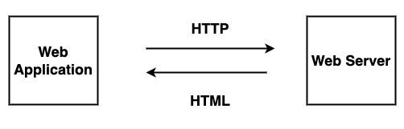
Without Ajax – traditional request – response communication

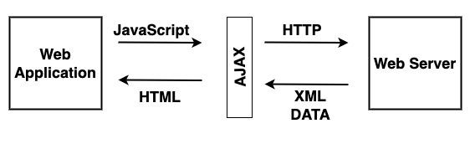
WITH AJAX REQUEST – COMMUNICATION BETWEEN WEB BROWSER AND WEB SERVER

<!DOCTYPE html>
<html>
<body>
<h1>Reading text file using AJAX</h1>
<div id="notes">
<h2>The XMLHttpRequest Object</h2>
<button type="button" onclick="loadDoc()">Change Content</button>
</div>

<script>
function loadDoc() {
const xhttp = new XMLHttpRequest();
xhttp.onload = function() {
document.getElementById("notes").innerHTML =
this.responseText;
}
xhttp.open("GET", "ajax_notes.txt");
xhttp.send(); // call the sending
}
</script>
</body>
</html>

<!DOCTYPE html>
<html>
<style>
table,th,td {
border : 1px solid black;
border-collapse: collapse;
}
th,td {
padding: 5px;
}
</style>
<body>
<button type="button" onclick="loadXMLDoc()">Get my CD collection </button>
<br><br>
<table id="demo"></table>

<script>
function loadXMLDoc() {
const xhttp = new XMLHttpRequest();// constructor
xhttp.onload = function() {
const xmlDoc = xhttp.responseXML;
const cd = xmlDoc.getElementsByTagName("CD");
myFunction(cd)
}
xhttp.open("GET", "cd_catalog.xml");
xhttp.send();
}

function myFunction(cd) {
let table="<tr><th>Artist</th><th>Title</th></tr>";
for (let i = 0; i < cd.length; i++) {
table += "<tr><td>" +
cd[i].getElementsByTagName("ARTIST")[0].childNodes[0].nodeValue +
"</td><td>" +
cd[i].getElementsByTagName("TITLE")[0].childNodes[0].nodeValue +
"</td></tr>";
}
document.getElementById("demo").innerHTML = table;
}
</script>
</body>
</html>
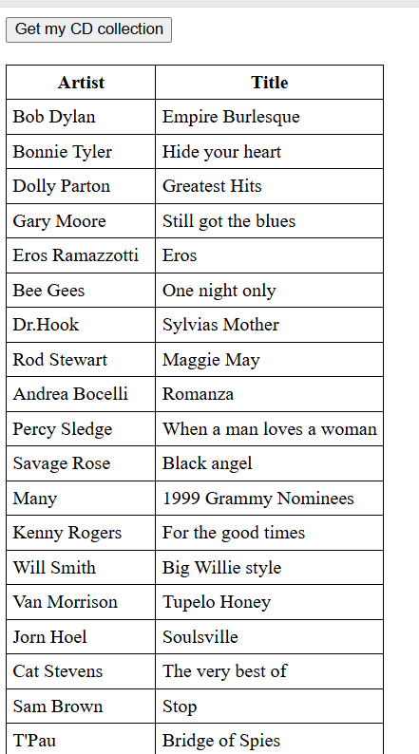

ajaxRun.js - file contents
function ajaxRun() {

// Creating Our XMLHttpRequest object
let xhr = new XMLHttpRequest();

// Making our connection
let url = 'https://jsonplaceholder.typicode.com/todos/1';
xhr.open("GET", url, true);

// function execute after request is successful
xhr.onreadystatechange = function () {
if (this.readyState == 4 && this.status == 200) {
console.log(this.responseText);
}
}
// Sending our request
xhr.send();
}
ajaxRun();
// reading todo list from other website or url
<!DOCTYPE html>
<html>
<body>
<h1>log the data todo from website url </h1>
<script>
function handleResponse() {
// Creating XMLHttpRequest object
var qhttp = new XMLHttpRequest();
// Creating call back function
qhttp.onreadystatechange = function() {
if (qhttp.readyState == 4){
if(qhttp.status == 200){
// Display the response
console.log(qhttp.responseText)
}else{
console.log("Found Error: ", qhttp.status)
}
}
};
// Open the given file
qhttp.open("GET", "https://jsonplaceholder.typicode.com/todos", true);
// Sending request to the server
qhttp.send()
}
</script>
<h2>Display Data</h2>
<button type="button" onclick="handleResponse()">Submit</button>
<div id="sample"></div>
</body>
</html>
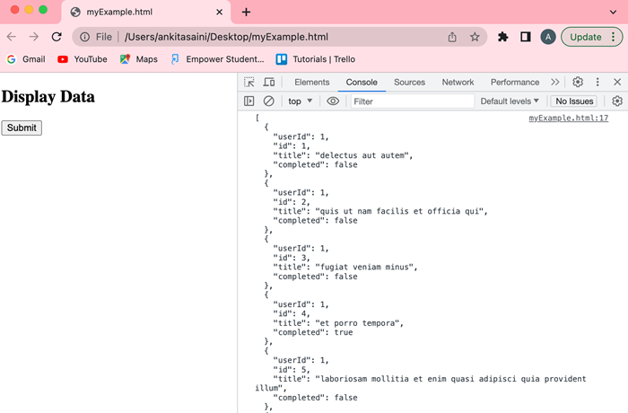

<!DOCTYPE html>
<html>
<body>

<h2>The XMLHttpRequest Object</h2>
<p>The getAllResponseHeaders() function returns all the header information of a resource, like length, server-type, content-type, last-modified, etc:</p>

<pre id="demo"></pre>

<script>
const xhttp = new XMLHttpRequest();
xhttp.onload = function() {
document.getElementById("demo").innerHTML =
this.getAllResponseHeaders();
}
xhttp.open("GET", "ajax_info.txt");
xhttp.send();
</script>

</body>
</html>

